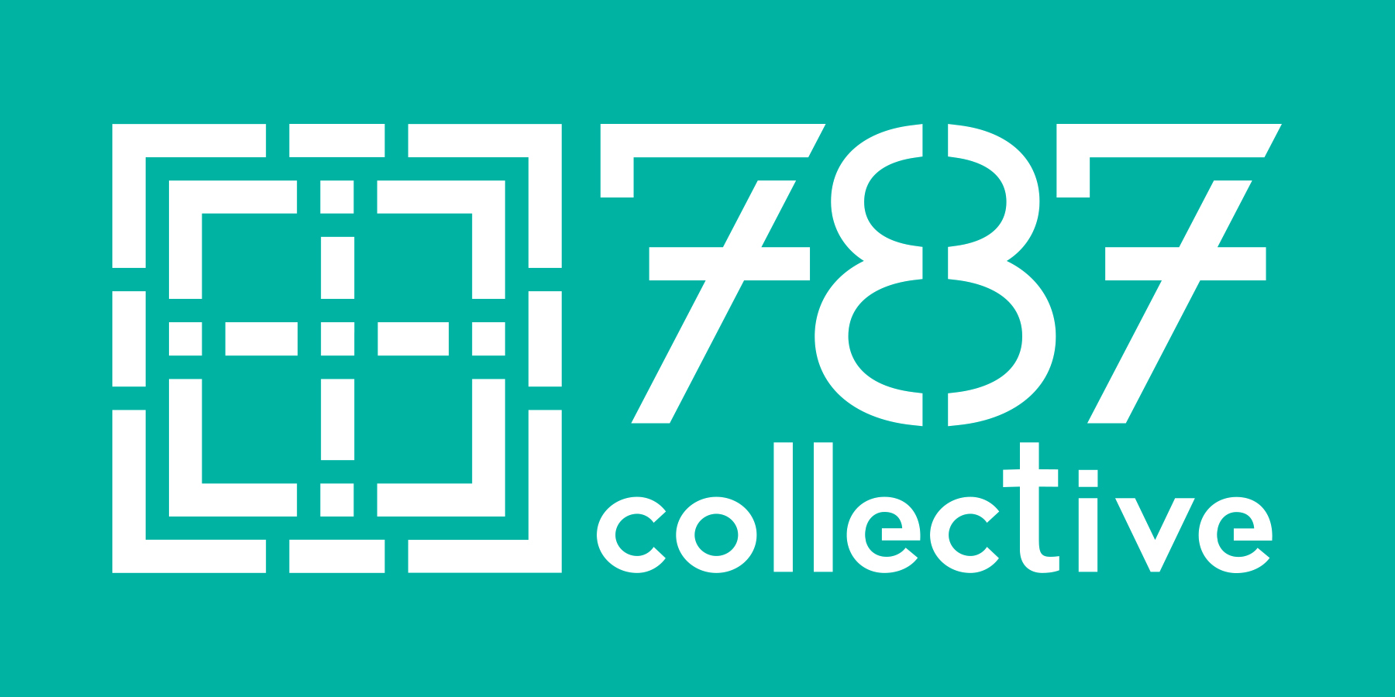
YOUNG ADULT
EXPRESSION OF INTEREST
Name:
Address:
Email: Phone: Age:
Were you previously or are you currently affiliated with a congregation? If so, please list their name and location here:
What do you see as three greatest personal or spiritual needs of young adults in Austin?

What do you see as three things that the church might have to offer to current and future generations?

How did you hear about this opportunity?
Please submit the following two items :
1. A letter to a congregation. Tell them what you want them to know about you, and about your desires to (1) engage a one-year experiment of response to the needs and passions of young adults in the community, and (2) engage in a mutual relationship with a congregation. This may include your own commitments to the community of Austin or your peers, some history or sustained questions and/or desires you have in your own faith or spiritual journey, your curiosity about congregational life, or your desire to provide a space of spiritual and personal nurture for your peers that could find a home within an intergenerational context. The letter should not be more than one page.
2. A current version of your resume or CV. Please include the name and phone number of three references who can speak to either your strength of character or your work ethic, or both.
*Following receipt of this form, a 787 Collective Staff member will connect with you about your interest in this project.

