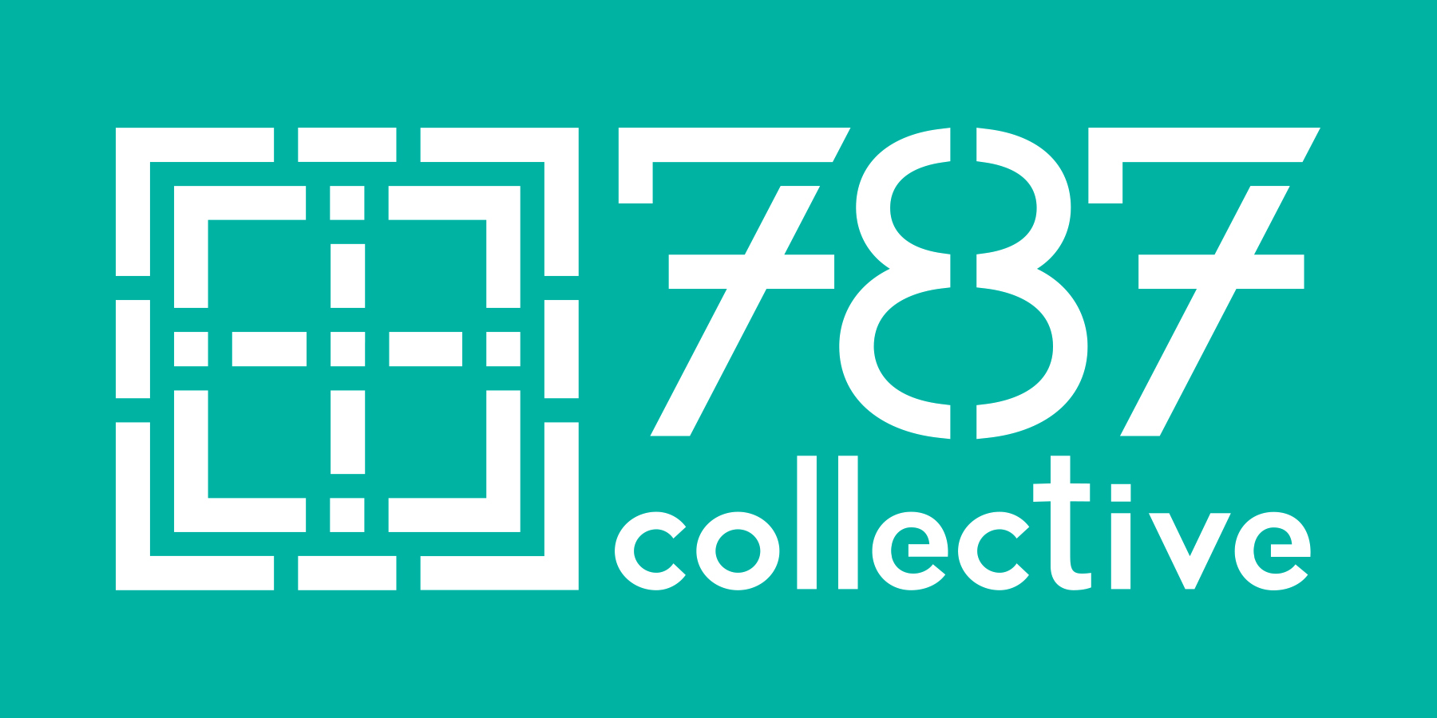
CONGREGATIONAL
EXPRESSION OF INTEREST
Name of Congregation:
Address:
Telephone: Website:
Name of Pastor: Email:
Size of congregational worshipping community: ____ 50 or fewer ____ 50-125 ____ 125-200____ 200-350 ____ More than 350
Geographical location: ____ Rural _____ Urban ____ Suburban ____ Small town _____ Other
Racial composition:
____ Majority Anglo ____ Majority Hispanic ____ Majority African American ____ Multi-racial ____ Other
Is there a young adult within your congregation whom you would like to nominate as your Young Adult Community Builder? If they are in agreement with this nomination, please include their name and email:
Name: Email:
Each project requires commitment from a member of the Pastoral Staff and one lay person to begin. We hope and expect additional lay people will join.
Committed Member of Pastoral Staff:
Name: Email:
Committed Lay Member:
Name: Email:
Please submit the following two items :
1. Compose a letter of invitation to a Young Adult Community Builder. What do you want them to know about your congregation and why you are willing to invest in this project? This may include gifts you have to offer for the young adult's enrichment, unfulfilled hopes for intergenerational community that includes young adults, or a sense of call to address needs or follow passions of young adults.
2. Please submit 2-3 stories (written or audio recorded) that illustrate moments when the church has embodied what it hopes to be for each other and/or for the community. These can be short. One suggestion is to ask a few lay people to describe one of their best or most powerful memories or moments during their time as a member of the congregation. If written, a paragraph or two suffices. These don’t need to be long, but simply need to be cohesive. If you want to try audio recording but need help, let us know and we will work with you!

