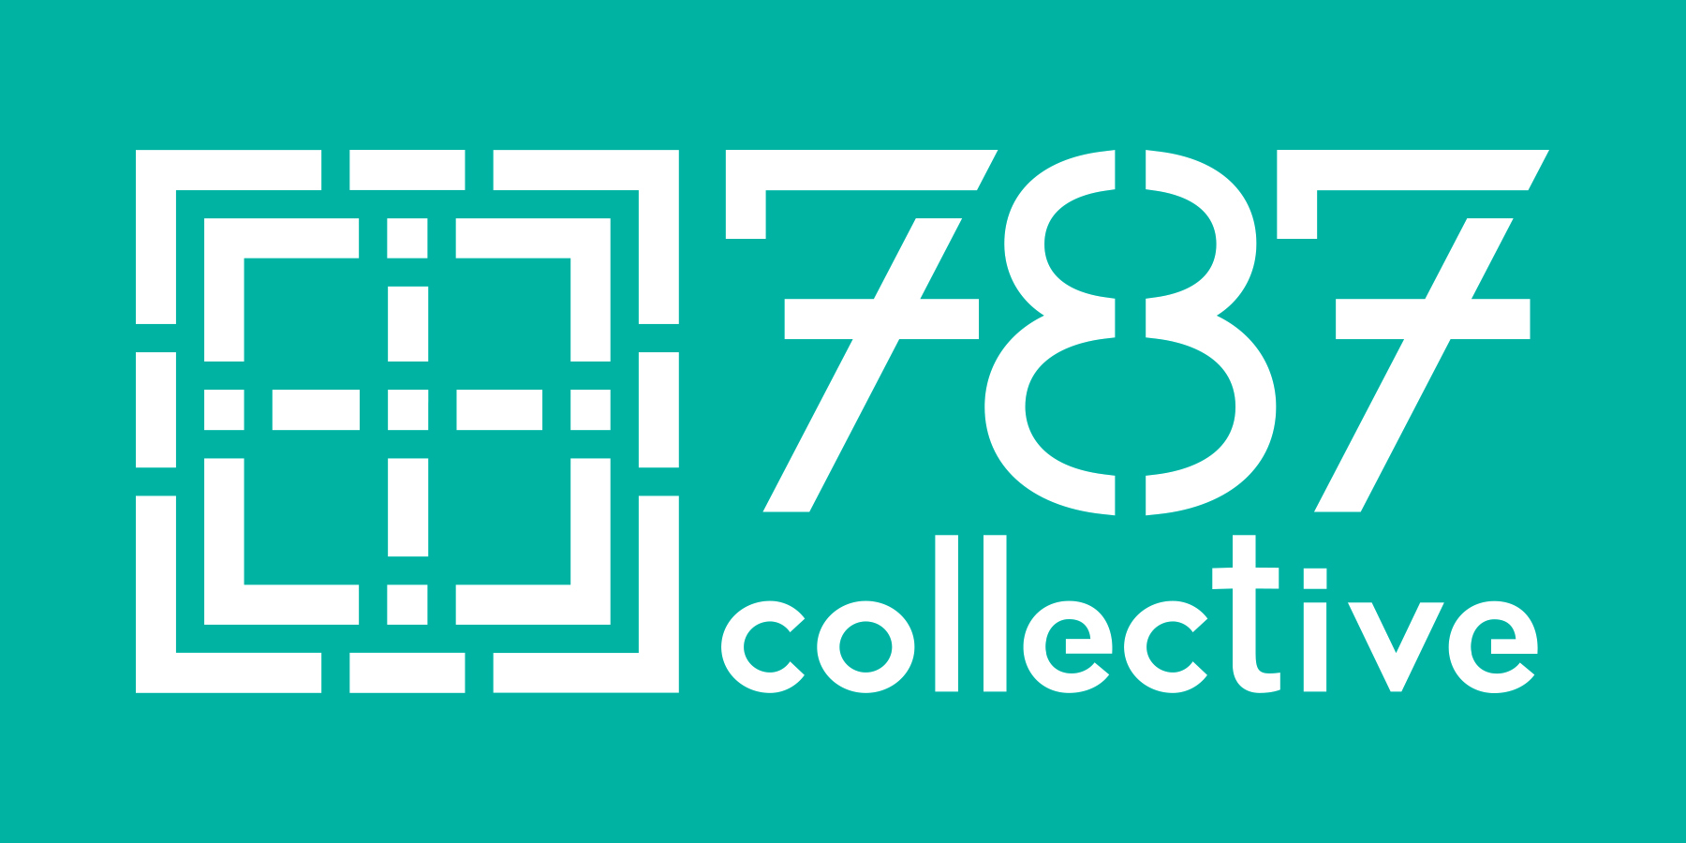
THE CHRISTIAN PRACTICE
OF DISCERNMENT
Discernment comes from the Latin word discernere that translates “to separate” “to sort” or “to determine.” In its simplest definition, discernment is the intentional effort to distinguish God’s voice from other voices that influence us. Discernment involves cultivating a prayerful, informed, open and honest listening space so that the Spirit’s invitation might be heard and trusted.
Forget the former things; do not dwell on the past.
See, I am doing a new thing!
Now it springs up; do you not perceive it? Isaiah 43: 18-1
As Christians, we know how to make decisions between what is life-giving and what is destructive, but most of our decisions aren’t between good and bad. Most of our energy in the Church is spent distinguishing between what is good and what is better, between the movement of the Spirit and the stirring of our own anxiety and expectations.
No method or spiritual practice will force God’s revelation. God is a Mystery (“the spirit blows where it chooses” John 3:8), and in discernment we are attending to our relationship with this living Mystery, rather than following a set of plans or principles. Discernment is more like a dance in which we seek to attend, respond, and ultimately partner with the movement of the Spirit.
Just as discernment opens us to God, it is equally about knowing ourselves—what brings us life, what shuts us down. A decision can be life giving in one moment, and the opposite in another time and context. It is an art to know ourselves, to know our community, to know the way in which God is working within us and the people we serve.
What voices do you have to sort?
- A practical assessment that young adults are needed for a church’s future financial sustainability
- A growing anxiety that declining membership irrelevancy,
- Restlessness for new forms of ministry
- A real need for funds to shore up current ministry programs or positions.
- A personal longing among church staff to be part of a collegial ministry community
How do we know when we are discerning the voice of God?
Life is complex. Each of us is filled with various unconscious drives, expectations, and unhealed wounds that affect our ability to hear God’s voice.
In addition, our lives are woven within a variety of complex relationships—family, friends, workmates, children--that shape how we hear and know God. All of these energies and complexities intermingle with our sense of God’s call and presence.

How do we know when we are discerning the voice of God? The truth is we don’t in the present. We each have a creative capacity to misname God, to conjure God, to confuse our own unconscious motives, feelings, and inspirations with the prompting of the Holy Spirit. Just as the disciples often misunderstood the meaning of Jesus’ words and actions, we too can misinterpret the signs of God. However, as we seek to hear God’s call, over time, we can begin to trace the fruit of our seeking.
Parker Palmer, the devout Quaker teacher and activist, writes in his book Let Your Life Speak that when a person or community is discerning a call, over time, way will open or way will close. In retrospect, many of us have probably experienced similar phenomena in our own lives when big decisions were on the line. It can feel like a random set of circumstances, or a gentle nudging. Discernment invites us to pay attention to these feelings and events as we determine whether way is opening or closing around the heart and capacity for this work.
Ultimately, discernment is an invitation to deepen our relationship with God, ourselves, and others. The hope of this guide and of any discernment process is that you will gain deeper clarity about yourself, your relationship to others, and God’s presence in your life and the life of your community.
Things to notice if way is closing
- A feeling of being more and more burdened
- A sense of greater anxiety, feeling that things are closing in
- Feelings of judgment and self-righteousness
- A lack of the fruits of the Spirit as you imagine following this calling

Things to notice if way is opening
- Signs of alignment or synchronicity
- A sense of curiosity or excitement
- Fruits of the Spirit showing up (patience, generosity, kindness, love, peace, joy)
- A sense of heart opening
- A feeling of grace
- A sense that things are “clicking” in the group or around the project itself
- The larger community affirms what the core group is seeing and experiencing
- Alignment with the mission of your church and the way of Jesus
- A pervasive sense of YES

Contents excerpted from The 787 Collective’s Discernment Guide, ©2017

